TESTING STRATEGIES

Software testing is a process of ensuring acceptable degree of quality attributes of software. Testing is the process of finding the errors introduced at any stage of development.

For implementation of any project testing is necessary, as in our CANTEEN AUTOMATION SYSTEM we need to test whether our system is error free and well organized or not.

There are various testing stratergies which are made for different software testing like static and dynamic analysis,different types of testing like black -box , white -box there are different levels of testing which are applied during testing of software.

**LEVELS OF TESTING-**

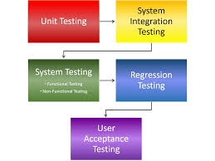

Every software is tested differently based on its model and stage of development.

For CANTEEN AUTOMATION SYSTEM testing strategies applied would be-

1. **DYNAMIC ANALYSIS** – For dynamic testing the test objects are executed or simulated .Dynamic analysis is what is generally considered as testing i.e. it involves running the system which is very important in canteen automation because it is totally deals with delivering of food material , and for testing this system running the system is very important to check whether the food is delivered on time or not what is the quality of food and many more things..so dynamic analysis is preferred over static analysis.

The activities for dynamic testing are-

1. Preparation of the test object for error localization.
2. Availability of a test environment.
3. Selection of appropriate test cases and data.
4. Test execution and evaluation.

In this way dynamic analysis is performed.

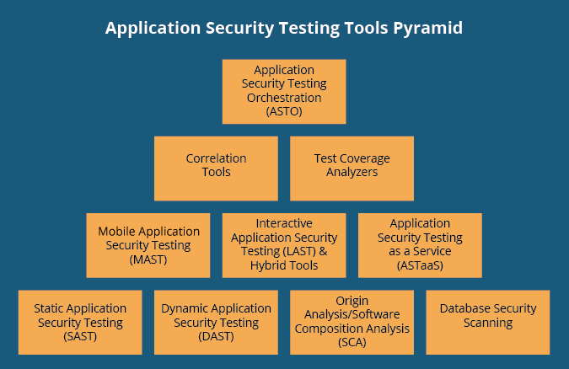

1. **Black-box Testing** – Functional or black-box testing is an approach to testing where the tests are derived on the basis of the requirements or specifications of the program or module and the internals of the program are not considered . Functional testing refers to testing which involves mainly observation of the output for some input and there is no attempt to analyses the code , which produces the output.

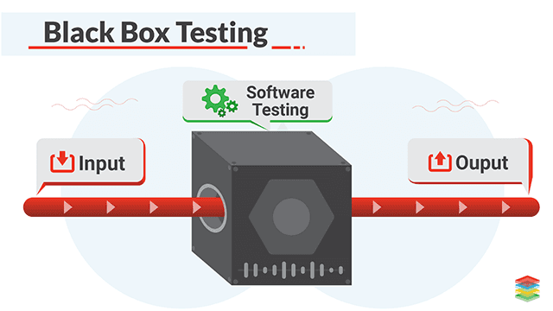

For the CANTEEN AUTOMATION SYSTEM black-box testing is a good approach for testing the system as the observation of the output is very necessary or rather we should say checking the functionality of system is important. Black-box testing is efficient when used on larger systems.

SO for this project this strategies of testing can be applied.